CMPS 350 Web Development

Project Phase1- Get Glammed e-commerce platform.

<https://github.com/lama-la2103717/WebProject>

Team members:

Lujayn Alamir 201901343___ contribution: 33.3%

Ekram Omer 202105434___contribution: 33.3%

Lama Albanna 202103717___contribution: 33.3%

Instructor: Mucahid Kutlu

Spring 2024

1. **Class diagram:**
2. **Use Cases documentation:**

**Use Case 1: Login**

* 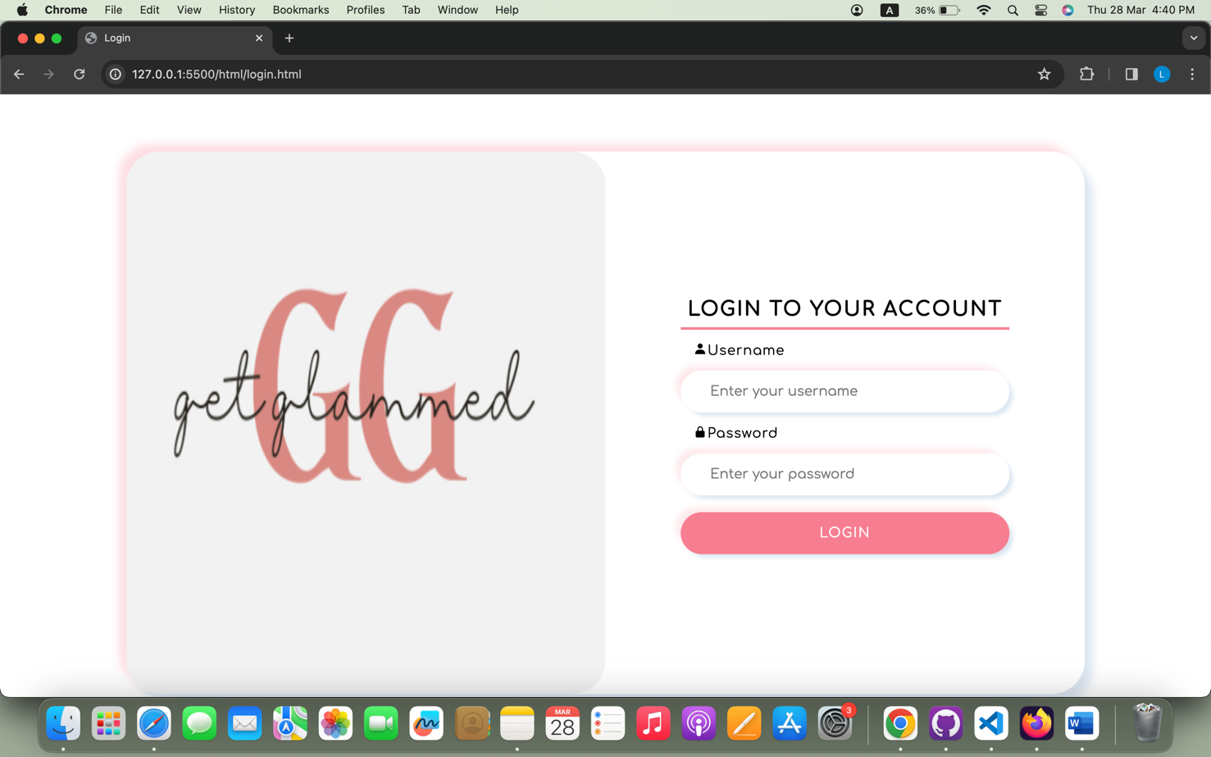In large screen:
* In small screen:

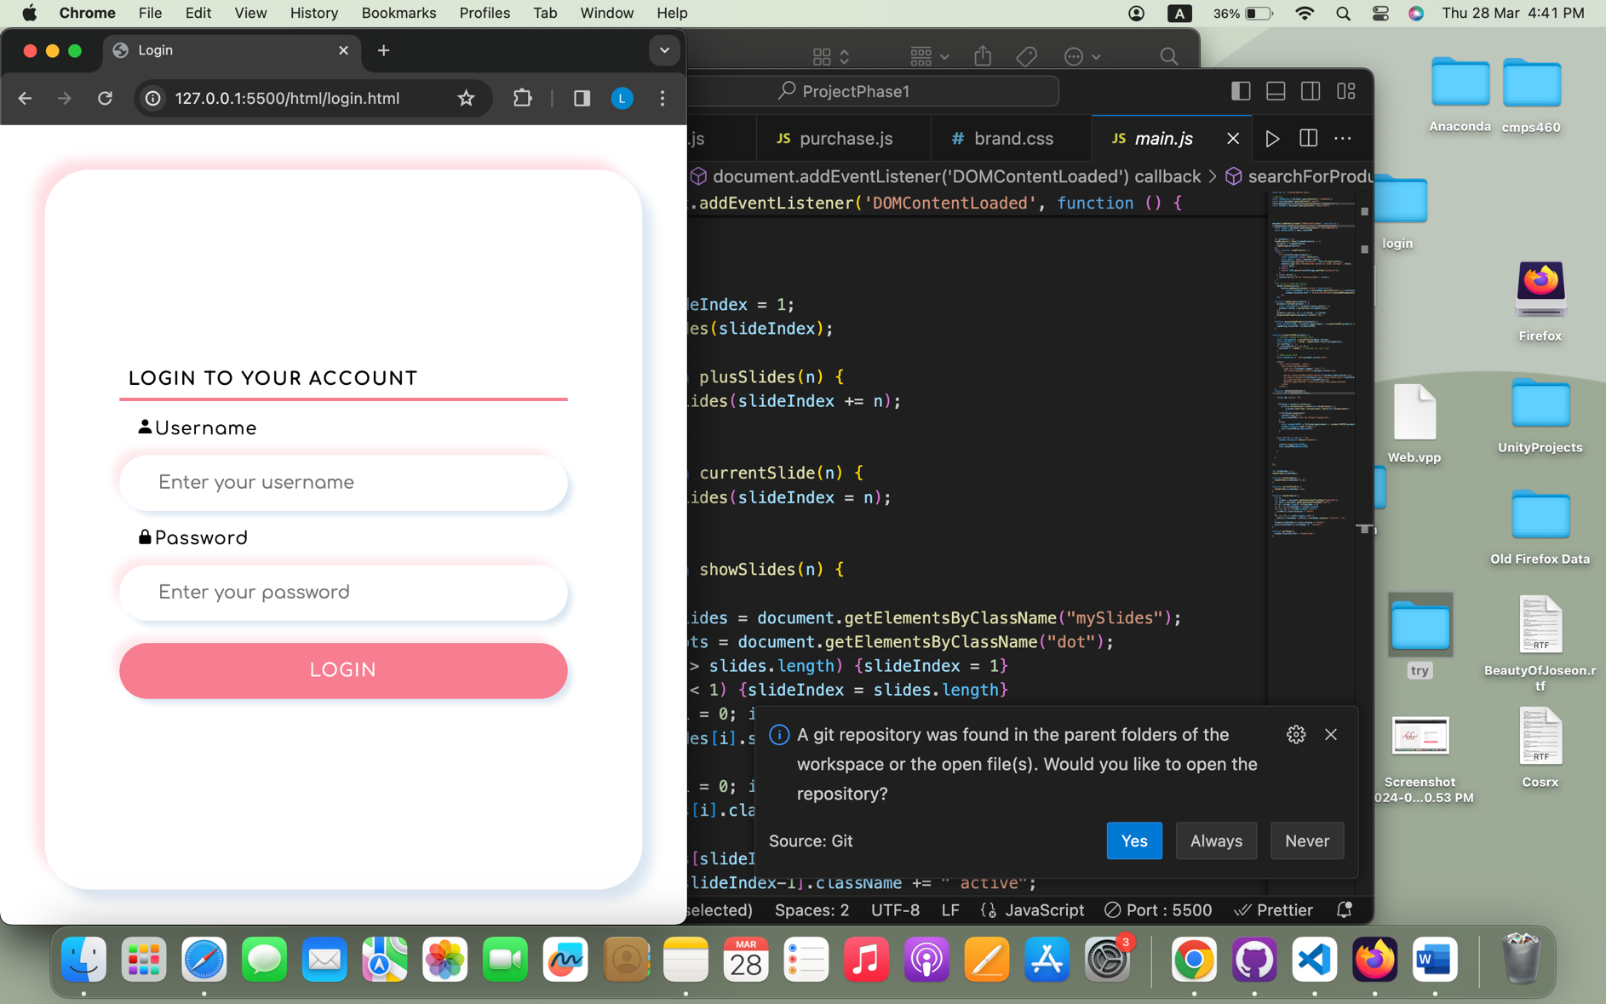

* 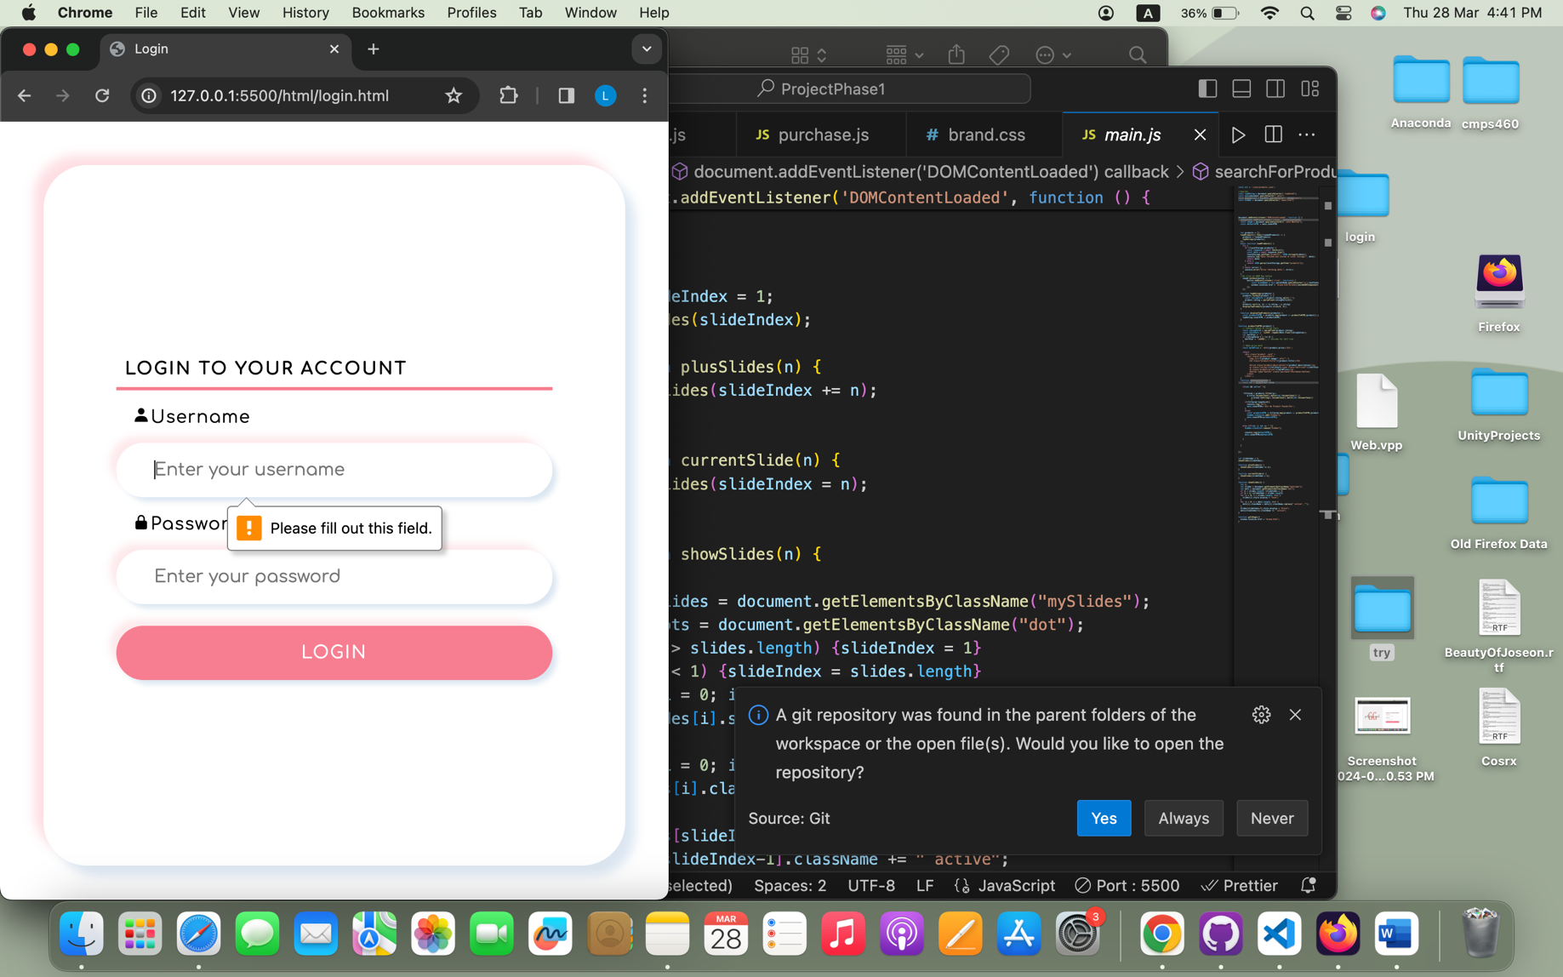If the user did not enter anything:
* If the user enter a username or password that is not in users.json , the user will get an alert:

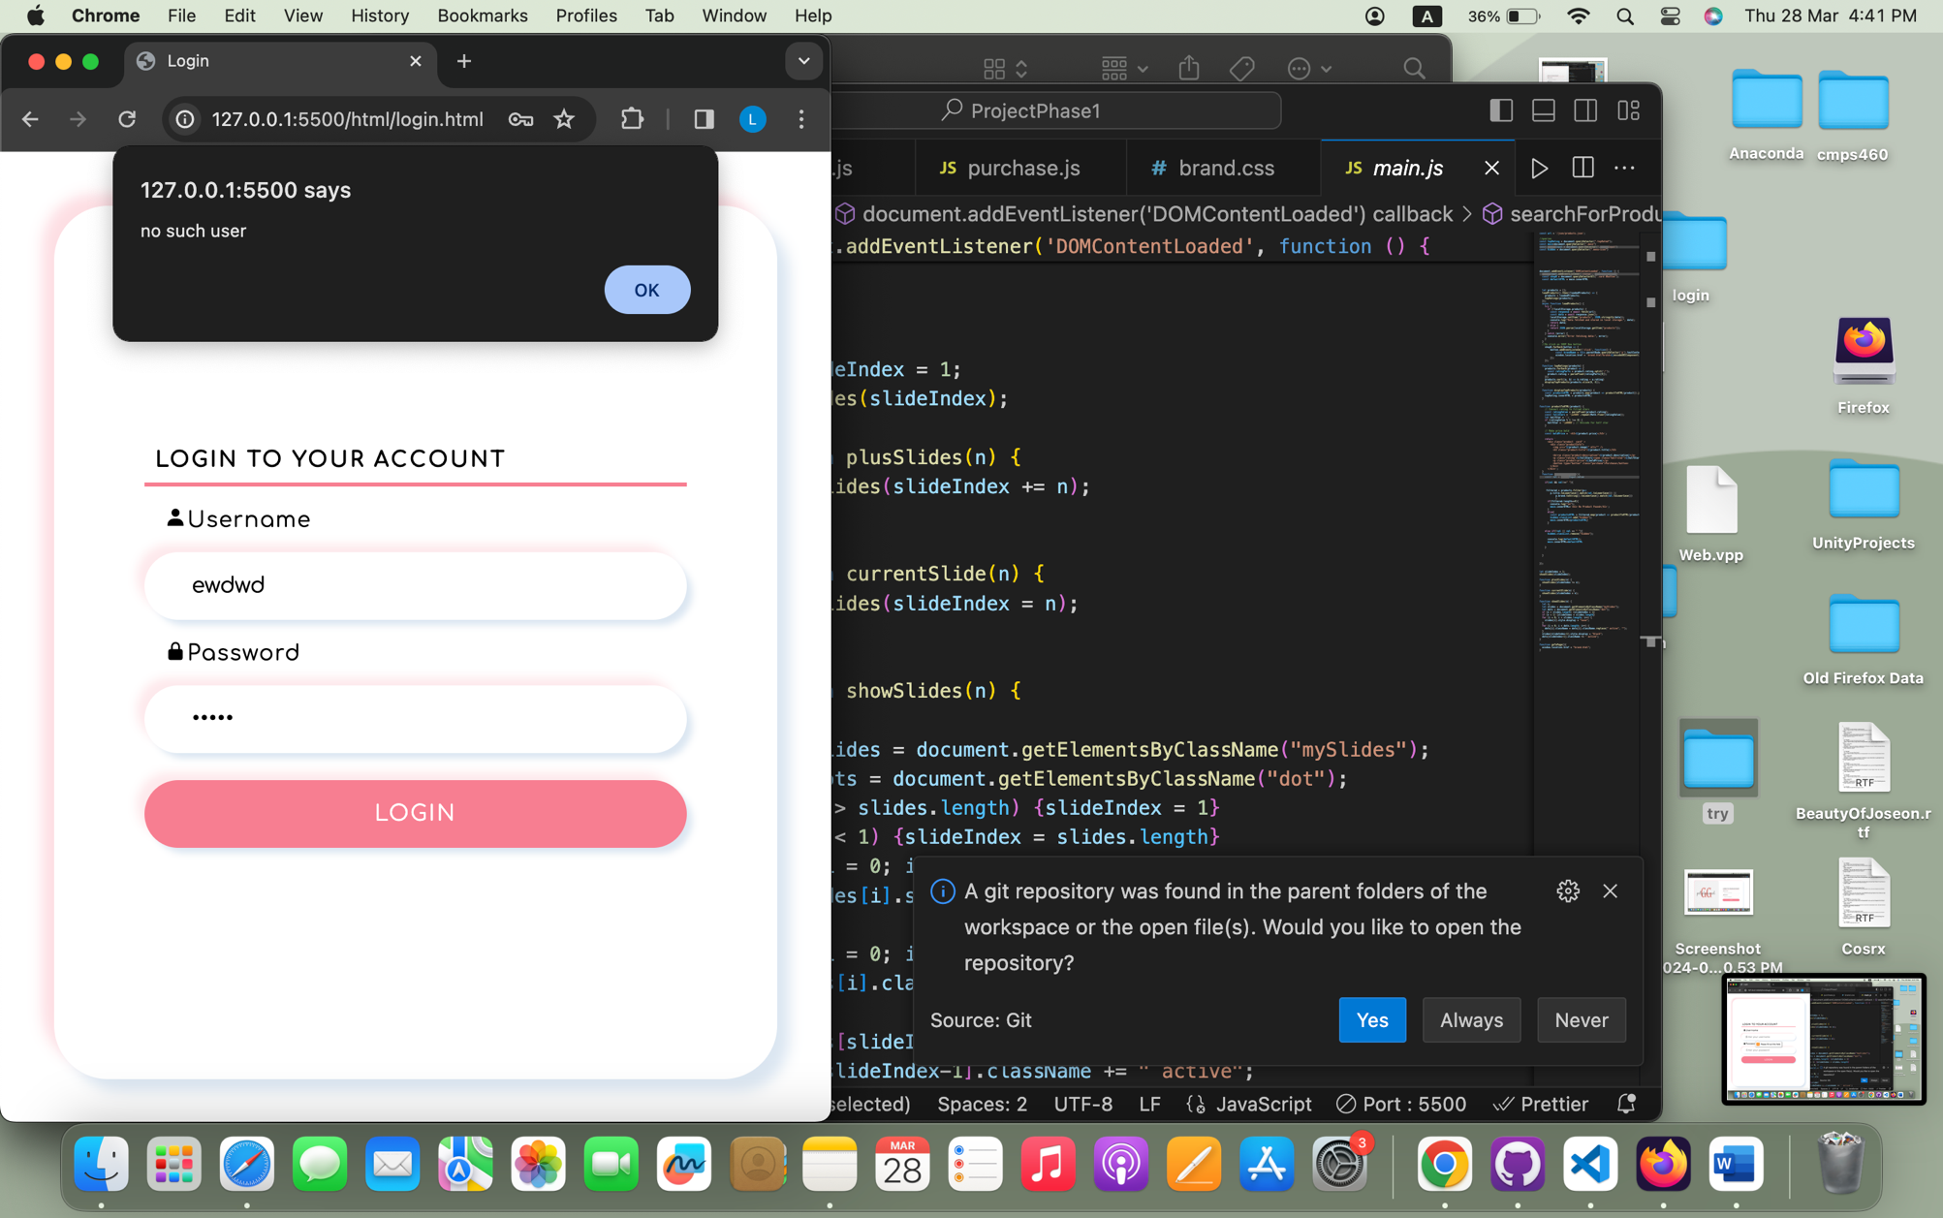

* If the user entered the username and password that is in users.json , the user will be directed to the main page.

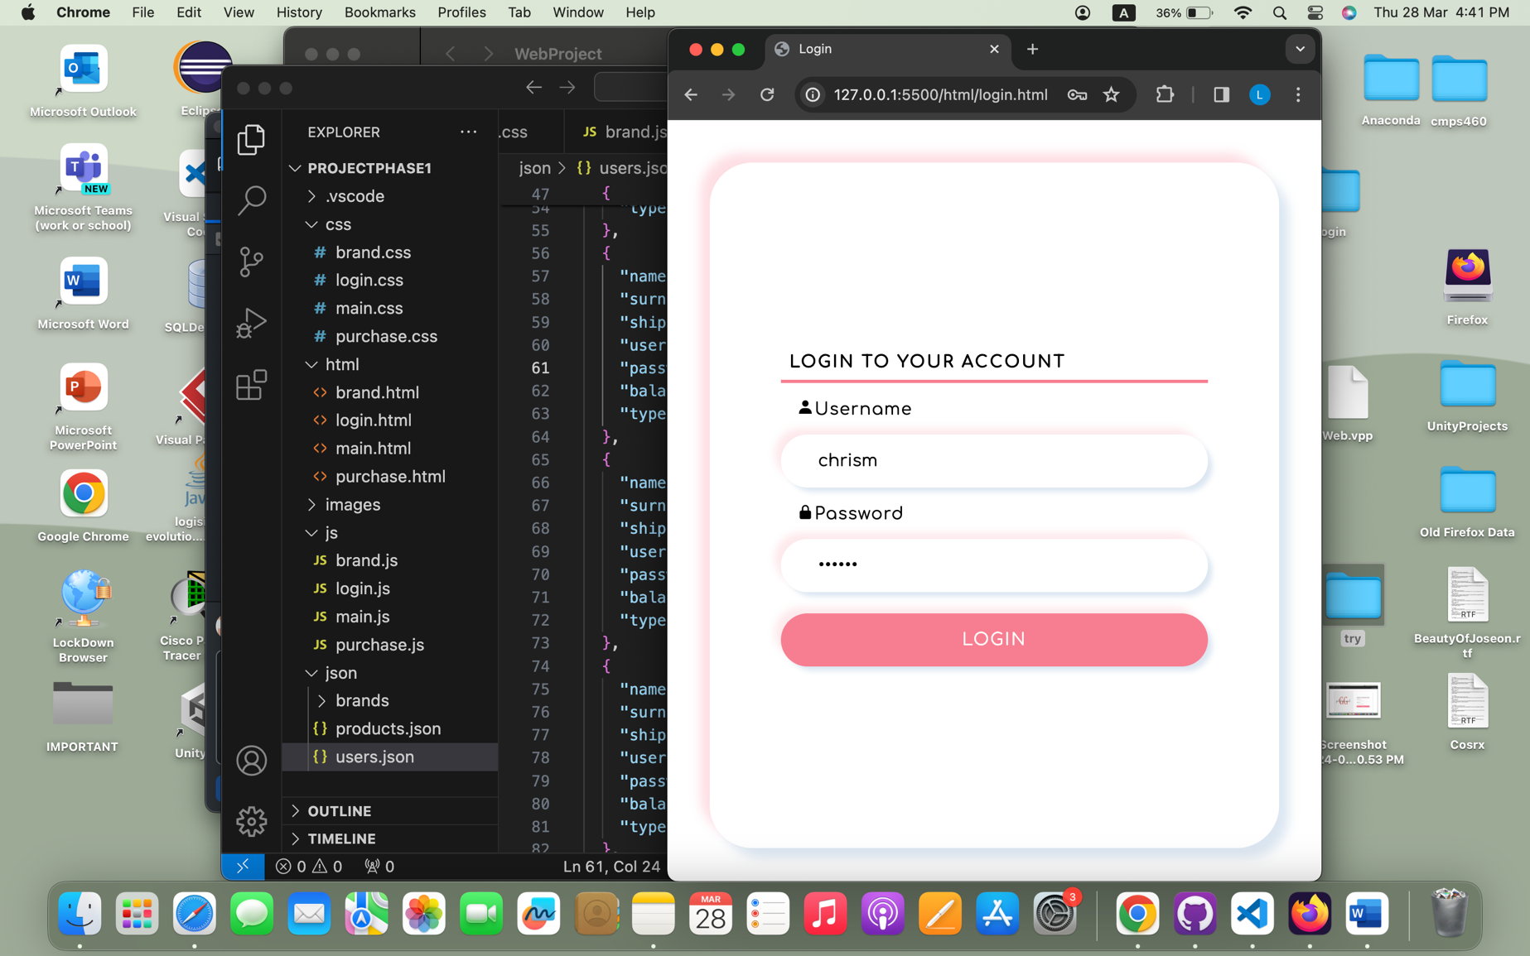

**Use Case 2: Search available items**

**Use Case 3: Purchase an item**

**Use Case 4: View the purchase history**

**Use Case 5: View available items on sale and sale history**

**Use Case 6: Upload an item to be sold**